***DEVELOPMENT PART 1***

**Importing Necessary Libraries**

Before we can start digging into datasets, we need to equip ourselves with Python's data preprocessing tools. The good news is that Python has a fantastic ecosystem of libraries that will make our data cleaning and wrangling much easier. In this step, we'll import three essential packages - Pandas, NumPy, and scikit-learn.

Pandas is the bread and butter for working with tabular data in Python. It provides easy-to-use data structures and functions for exploring, manipulating, and analyzing datasets.

To import these libraries, simply run the following code:

import pandas as pd

import NumPy as np

from sklearn import preprocessing

Now we have the full power of Pandas, NumPy, and scikit-learn at our fingertips. With this utility belt equipped, we can start wielding these tools to whip our datasets into shape.

Ezoic

## Data Loading and Understanding

Now that our preprocessing libraries are imported, it's time to load our raw data and start getting familiar with it. In doing so, one might find it useful to explore the [Python Dash vs Streamlit](https://www.firebolt.io/python-tools-comparison/dash-vs-streamlit) comparison. Both these platforms offer powerful capabilities for data loading and exploration, making it easier to understand the intricacies of your dataset.

We'll start by loading a sample CSV dataset containing housing price data for different regions. Using Pandas' read_csv() method makes this a breeze:

housing = pd.read_csv('housing.csv')

With our DataFrame loaded, we can now use Pandas' convenient attributes like .head() and .info() to explore the data. Visualizing the data with plots and charts also provides useful insights. This high-level investigation allows us to understand the properties of each variable, spot errors or anomalies, and inform our preprocessing strategy.

## Handling Missing Data

Now that we've loaded and explored our data, it's time to address one of the most common data preprocessing tasks - handling missing values. Most real-world datasets contain some amount of missing data due to human error, equipment malfunctions, or respondents skipping questions. If not addressed properly, missing data can reduce model accuracy and lead to misleading analytical insights. Some strategies for handling missing values in Python include:

* Deletion - Removing rows or columns containing missing values
* Imputation - Replacing missing values with the mean, median, or mode
* Modeling - Using machine learning to predict missing values based on other columns

## Data Transformation

Once the missing data is handled, the next step is data transformation. This process involves modifying the data in a way that enhances its suitability for analysis or model building.

One type of transformation is scaling, which is crucial when dealing with features that exist on different scales. Machine learning algorithms can be biased towards variables with higher magnitudes – think of a dataset that includes age (a two-digit number) and salary (a five or six-digit number).

scaler = preprocessing.MinMaxScaler()

data['column_name'] = scaler.fit_transform(data[['column_name']])

Copy

Another transformation is normalization, which adjusts the distribution of data. Certain machine learning algorithms assume that the input data is normally distributed, or follows a Gaussian distribution. If the data does not meet this assumption, we can use the PowerTransformer from scikit-learn to make it more Gaussian-like:

norm = preprocessing.PowerTransformer()

data['column_name'] = norm.fit_transform(data[['column_name']])

**Encoding Categorical Data**

Most interesting datasets contain categorical variables like country, genre, or status. Machine learning algorithms prefer numerical data, so encoding categoricals is crucial. In this step, we'll learn techniques for converting categorical columns into numeric formats.

The two main encoding methods are:

* **One-hot encoding** - Creating new columns indicating the presence (1) or absence (0) of each category value.
* **Label encoding** - Assigning a numeric code to each unique category label.

In Python, we can implement one-hot encoding using Pandas' get_dummies() method or scikit-learn's OneHotEncoder class. For label encoding, scikit-learn's LabelEncoder works great.

## Final Thoughts

Mastering data preprocessing is a fundamental step in your data analysis and machine learning journey. It allows you to transform raw, messy data into clean, understandable input that can be used to create accurate and efficient models. While it may seem tedious and uninteresting, proper data preprocessing can make a huge difference in your project's outcome. Put these Python tools into practice, and you'll be well on your way to becoming an expert data wrangler.

***Learn also:*** [*Data Cleaning with Pandas in Python*](https://thepythoncode.com/article/data-cleaning-using-pandas-in-python).

# ***Website Traffic Using IBM Cognos for virtualization***

Table of Contents

* [**Understanding the Importance of Website Traffic**](https://zebrabi.com/guide/how-to-improve-website-traffic-using-ibm-cognos-analytics/#Understanding_the_Importance_of_Website_Traffic)
* [**Introduction to IBM Cognos Analytics**](https://zebrabi.com/guide/how-to-improve-website-traffic-using-ibm-cognos-analytics/#Introduction_to_IBM_Cognos_Analytics)
* [**Leveraging IBM Cognos Analytics for Website Traffic Improvement**](https://zebrabi.com/guide/how-to-improve-website-traffic-using-ibm-cognos-analytics/#Leveraging_IBM_Cognos_Analytics_for_Website_Traffic_Improvement)
* [**Note: These subheadings are SEO-friendly and provide a comprehensive overview of the article content related to improving website traffic using IBM Cognos Analytics**](https://zebrabi.com/guide/how-to-improve-website-traffic-using-ibm-cognos-analytics/#Note_These_subheadings_are_SEO-friendly_and_provide_a_comprehensive_overview_of_the_article_content_related_to_improving_website_traffic_using_IBM_Cognos_Analytics)

## Understanding the Importance of Website Traffic

Before we dive into the specifics of using IBM Cognos Analytics, let's take a moment to understand why website traffic is so important. Website traffic is essentially the number of visitors your website receives over a given period of time. It serves as a key performance indicator (KPI) for your online presence and can provide valuable insights into the effectiveness of your marketing efforts, user experience, and overall brand awareness.

## Introduction to IBM Cognos Analytics

IBM Cognos Analytics is a powerful business intelligence and data analytics platform that can help you gain deep insights into your website's performance and audience behavior. It enables you to collect, analyze, and visualize data from various sources, allowing you to make informed decisions and optimize your website traffic strategies.

With its user-friendly interface and robust features, IBM Cognos Analytics empowers marketers and business owners to extract meaningful insights from their data and drive actionable improvements.

## Leveraging IBM Cognos Analytics for Website Traffic Improvement

Now let's explore some specific ways in which you can leverage IBM Cognos Analytics to improve your website traffic.

1. **Analyzing Website Traffic Data with IBM Cognos Analytics:** One of the first steps in improving website traffic is to analyze your existing data. With IBM Cognos Analytics, you can easily gather data from various sources, such as website analytics tools like Google Analytics, social media platforms, and customer relationship management (CRM) systems.

2. **Key Metrics to Track for Website Traffic Improvement:** IBM Cognos Analytics provides a wide range of metrics and KPIs that you can track to measure the effectiveness of your website traffic strategies. Some important metrics to consider include total website visits, unique visitors, bounce rate, time on site, conversion rate, and click-through rate.

3. **Setting Up IBM Cognos Analytics for Website Traffic Analysis:** To get started with IBM Cognos Analytics, you need to set up the platform and configure it to collect data from your website and other relevant sources. This may involve integrating IBM Cognos Analytics with your website's tracking tools, CRM system, and other data sources.

4. **Using IBM Cognos Analytics to Identify Target Audience and Market Segments:** Understanding your target audience is crucial for driving relevant traffic to your website. With IBM Cognos Analytics, you can segment your website traffic based on various criteria, such as demographics, geographic location, referring websites, and user behavior.

5. **Improving SEO Strategies with IBM Cognos Analytics:** Search engine optimization (SEO) plays a vital role in increasing organic website traffic. IBM Cognos Analytics can provide valuable insights into keyword performance, search engine rankings, and organic traffic trends. By analyzing this data, you can identify opportunities to optimize your website's

6. **Optimizing Content Marketing Efforts Using IBM Cognos Analytics:** Content marketing is another powerful strategy for driving website traffic.

7. **Enhancing User Experience with Insights from IBM Cognos Analytics:** User experience (UX) plays a significant role in attracting and retaining website visitors.

8. **Utilizing Social Media Insights to Drive Website Traffic using IBM Cognos Analytics:** Social media platforms can be powerful drivers of website traffic.

9. **Tracking and Analyzing Referral Sources with IBM Cognos Analytics:** Referral traffic refers to visitors who land on your website from external sources, such as other websites, online directories, and social media profiles.

10. **Integrating Google Analytics with IBM Cognos for Comprehensive Website Traffic Analysis:** Google Analytics is a widely-used website analytics tool that provides in-depth insights into website traffic.

11. **Leveraging Predictive Analytics to Drive Website Traffic Growth with IBM Cognos:** Predictive analytics is a powerful technique that uses historical data and machine learning algorithms to forecast future trends and outcomes

12. **Implementing Data-Driven Strategies for Improved Website Traffic using IBM Cognos Analytics:** One of the biggest advantages of IBM Cognos Analytics is its ability to enable data-driven decision making.

13. **Creating Custom Reports and Dashboards in IBM Cognos Analytics for Better website traffic insights:** IBM Cognos Analytics allows you to create custom reports and dashboards that align with your specific website traffic goals.

14. **Measuring the Effectiveness of Marketing Campaigns with IBM Cognos Analytics:** Successful marketing campaigns can have a significant impact on website traffic.

15. **Harnessing the Power of Business Intelligence to Maximize Website Traffic using IBM Cognos:** Business intelligence (BI) refers to the process of using data and analytics to gain insights and make informed decisions.

16. **Best Practices and Tips for Increasing Website Traffic using IBM Cognos Analytics:** As with any tool or strategy, there are certain best practices and tips to keep in mind when using IBM Cognos Analytics to improve your website traffic.

## *Note: These subheadings are SEO-friendly and provide a comprehensive overview of the article content related to improving website traffic using IBM Cognos Analytics*

By following the strategies and utilizing the capabilities of IBM Cognos Analytics discussed in this article, you can take significant steps towards improving your website traffic and ultimately achieving your online business goals. Remember, driving traffic to your website is just the first step – it's equally important to focus on converting that traffic into leads and customers through effective marketing and sales strategies.

**How Do Website Traffic Analysis Tools Work?**

Tools for website traffic analysis look at important statistics that show the areas where your site is productive and where you need to make improvements.

These checkers scrutinize user behavior on your web pages and show calculated details about important key performance indicators (KPIs).

These KPIs include:

* **Traffic volume:** The number of new and returning visitors to your website along with their demographic info.
* **Traffic sources:** How users reached your site (e.g. organic search, sponsored ads, email, social media posts).
* **Page views:** The number of times people visit specific pages on the site.
* **Session duration:** The total amount of time a visitor spends on your website.
* **Bounce rate:** The proportion of visitors who landed at any of your webpages and then left without further interacting with the site.
* **Conversion rate:** The percentage of visitors that interact with a call to action on the website (such as submitting a form or purchasing a product). This interaction is known as [a conversion](https://kinsta.com/blog/conversion-rate-optimization-tips/).
* **Unique visits:** Counts only a person’s first visit, allowing you to separate potential clients from loyal users.
* **Exit pages:** Identifies the pages from which each visitor leaves your website.

Website traffic analysis is the process of collecting and interpreting key data points that describe web traffic to and from your site. (Web traffic is information about every user that visits your site.) While the general rule of thumb is the more traffic, the better, high traffic numbers alone don’t always translate to increased sales or lead generation.

Web traffic analysis breaks down data using specific metrics to organize that data and help you understand:

* Who’s visiting your site
* How long they're on your site
* What they’re doing while on your site
* Top of Form

Bottom of Form

Metrics matter in all aspects of business

This includes your website. To ensure your site is performing well and delivering conversions, you can deploy website traffic analysis tools to identify key trends, prioritize developing patterns, and streamline your site.

So, what does the process of website traffic analysis entail? What benefits does it offer and how does it work? And most importantly, what tools are available to help?

Let’s get started.

**Table of Contents**

[What is website traffic analysis?](https://blog.hubspot.com/website/website-traffic-analysis-tools#what)

[How do website traffic analysis tools work?](https://blog.hubspot.com/website/website-traffic-analysis-tools#how)

[What are the benefits of website traffic analysis?](https://blog.hubspot.com/website/website-traffic-analysis-tools#benefit)

[Tools for Website Traffic Analysis](https://blog.hubspot.com/website/website-traffic-analysis-tools#tool)

## What is website traffic analysis?

Website traffic analysis is the process of collecting and interpreting key data points that describe web traffic to and from your site. (Web traffic is information about every user that visits your site.) While the general rule of thumb is the more traffic, the better, high traffic numbers alone don’t always translate to increased sales or lead generation.

Web traffic analysis breaks down data using specific metrics to organize that data and help you understand:

* Who’s visiting your site
* How long they're on your site
* What they’re doing while on your site
* Most-likely reasons they leave your site

When you're equipped with accurate and immediate website traffic data, it’s possible to develop pattern models that identify potential weak points in your web design and inform ongoing development decisions.

The good news is there are a number of resources you can implement to help with your website traffic analysis. Next, let's look at how they work.

## How do website traffic analysis tools work?

Website traffic analysis tools work by measuring key metrics — datasets that highlight where your site is seeing success and where you may need to make improvements. Here are some common website traffic metrics your tools will likely measure:

### **1.**[**HubSpot CMS**](https://www.hubspot.com/products/cms?_ga=2.239051203.2104335201.1636376976-761207556.1636376976&hubs_content=blog.hubspot.com/website/website-traffic-analysis-tools&hubs_content-cta=HubSpot%20CMS&hubs_post=blog.hubspot.com/website/website-traffic-analysis-tools&hubs_post-cta=HubSpot%20CMS)

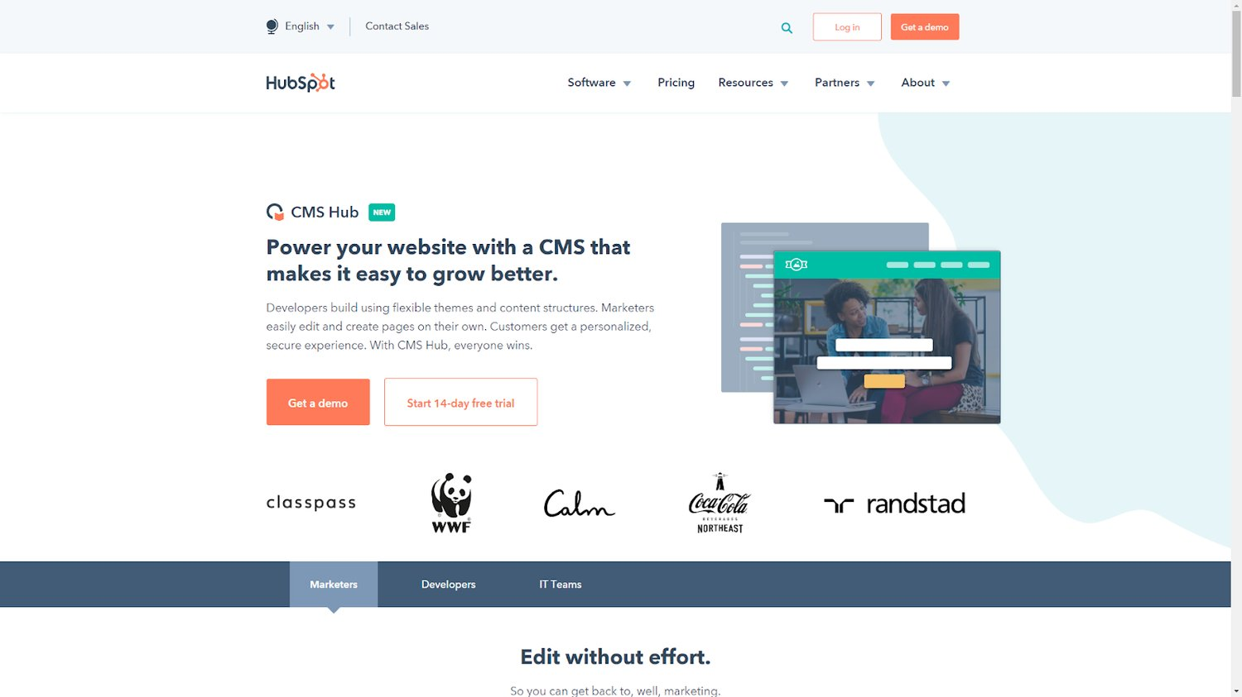

[Hubspot CMS](https://www.hubspot.com/products/cms?_ga=2.241681089.294683647.1587317053-1675356138.1572978608&hubs_content=blog.hubspot.com/website/website-traffic-analysis-tools&hubs_content-cta=Hubspot%20CMS&hubs_post=blog.hubspot.com/website/website-traffic-analysis-tools&hubs_post-cta=Hubspot%20CMS) offers powerful and customizable website traffic analysis tools. Combined with top-tier campaign, lead generation, and customizable form tools, HubSpot CMS is your one-stop-shop for website metrics, management, and marketing.

### **2.**[**Mouseflow**](https://mouseflow.com/)

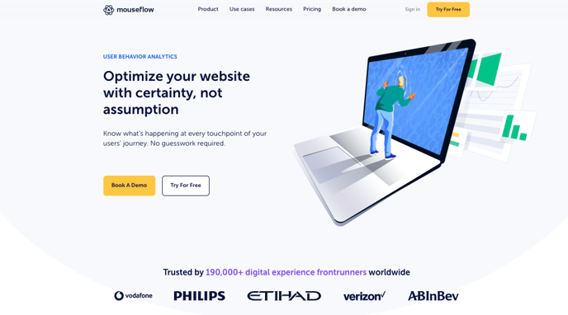

* Mouseflow lets you see *exactly* what your visitors see — easily replay the entire visitor experience to identify key pain points and make adjustments that lead to a boost in conversions.

### **3.**[**SimilarWeb**](https://www.similarweb.com/)

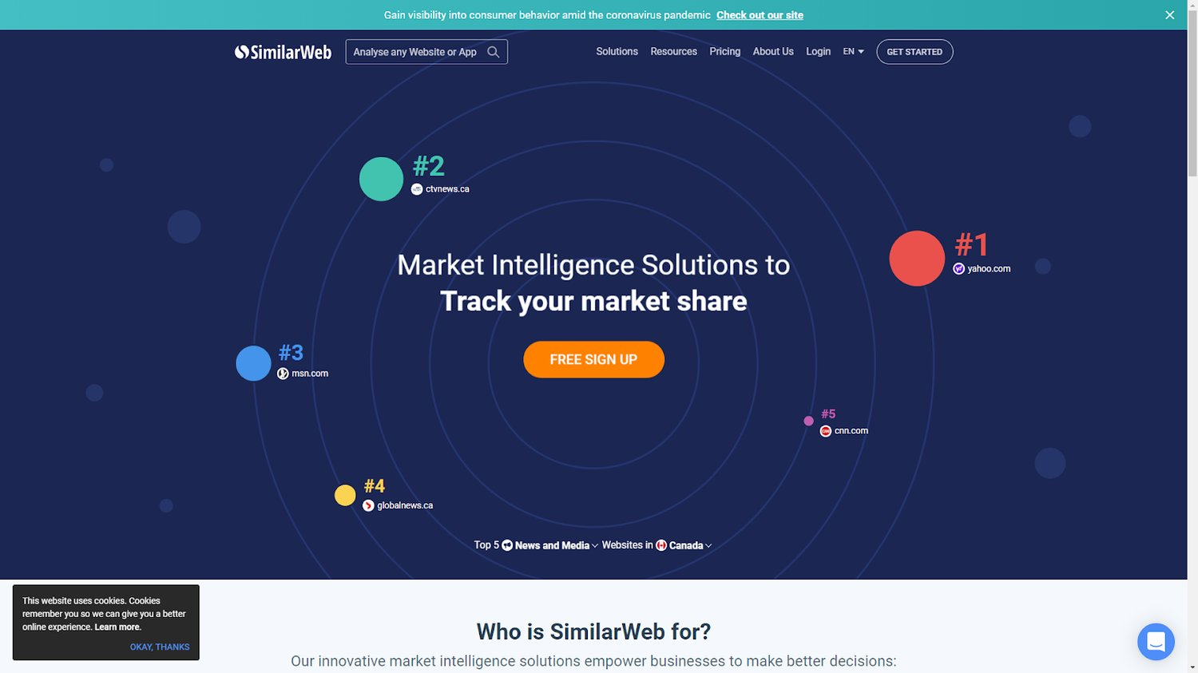

SimilarWeb is ideal for tracking your market share with benchmarks, trends, and traffic analysis. It gives you an understanding of what’s working on your site, what isn’t, and how you can improve.

SimilarWeb is free for limited tracking and traffic results.

### **5.**[**Google Analytics**](https://marketingplatform.google.com/about/analytics/)

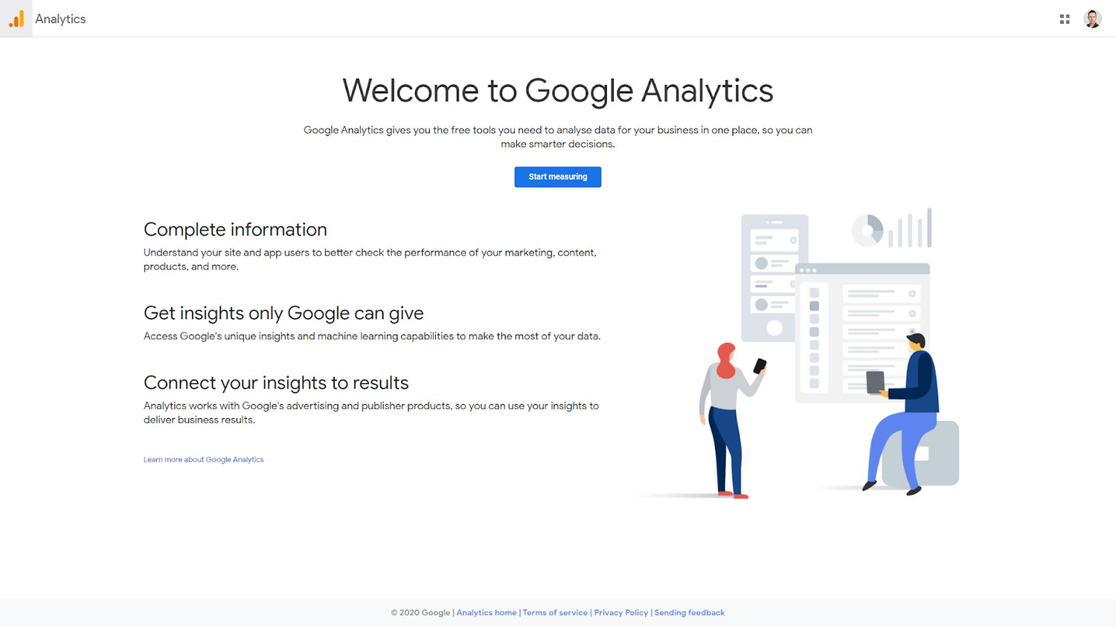

Arguably the king of free website traffic analysis, Google Analytics helps you build a complete picture of visitor preferences while connecting key insights to traffic results.

# **Data Cleaning Steps & Process to Prep Your Data for Success**

## What Is Data Cleaning?

[Data cleaning](https://monkeylearn.com/data-cleaning/) is the process of editing, correcting, and structuring data within a data set so that it’s generally uniform and prepared for analysis. This includes removing corrupt or irrelevant data and formatting it into a language that computers can understand for optimal analysis.

There is an often repeated saying in data analysis: “Garbage in, garbage out,” which means that, if you start with bad data (garbage), you’ll only get “garbage” results.

Data cleaning is often a tedious process, but it’s absolutely essential to get top results and powerful insights from your data.

[Try MonkeyLearn](https://monkeylearn.com/)

# **Data Cleaning Steps & Process to Prep Your Data for Success**



No matter what kind of [data analytics](https://monkeylearn.com/blog/data-analysis-examples/) you’re performing, your analysis and any other downstream processes are only as good as the data you start with.

Most raw data, whether text, images, video – often even data stored in spreadsheets – is improperly formatted, incomplete, or downright dirty and needs to be properly cleaned and structured before you begin your analysis.

There are a number of data cleaning, “data cleansing,” or “data scrubbing” techniques you can put to use to ensure your [data is properly prepared](https://monkeylearn.com/blog/data-preparation/) for analysis.

* [What Is Data Cleaning?](https://monkeylearn.com/blog/data-cleaning-steps/#what-is)
* [Data Cleaning Steps & Techniques](https://monkeylearn.com/blog/data-cleaning-steps/#steps)
* [Data Cleaning Tips](https://monkeylearn.com/blog/data-cleaning-steps/#tips)

## What Is Data Cleaning?

[Data cleaning](https://monkeylearn.com/data-cleaning/) is the process of editing, correcting, and structuring data within a data set so that it’s generally uniform and prepared for analysis. This includes removing corrupt or irrelevant data and formatting it into a language that computers can understand for optimal analysis.

There is an often repeated saying in data analysis: “Garbage in, garbage out,” which means that, if you start with bad data (garbage), you’ll only get “garbage” results.

Data cleaning is often a tedious process, but it’s absolutely essential to get top results and powerful insights from your data.

This is powerfully elucidated with the 1-10-100 principle: It costs $1 to prevent bad data, $10 to correct bad data, and $100 to fix a downstream problem created by bad data.

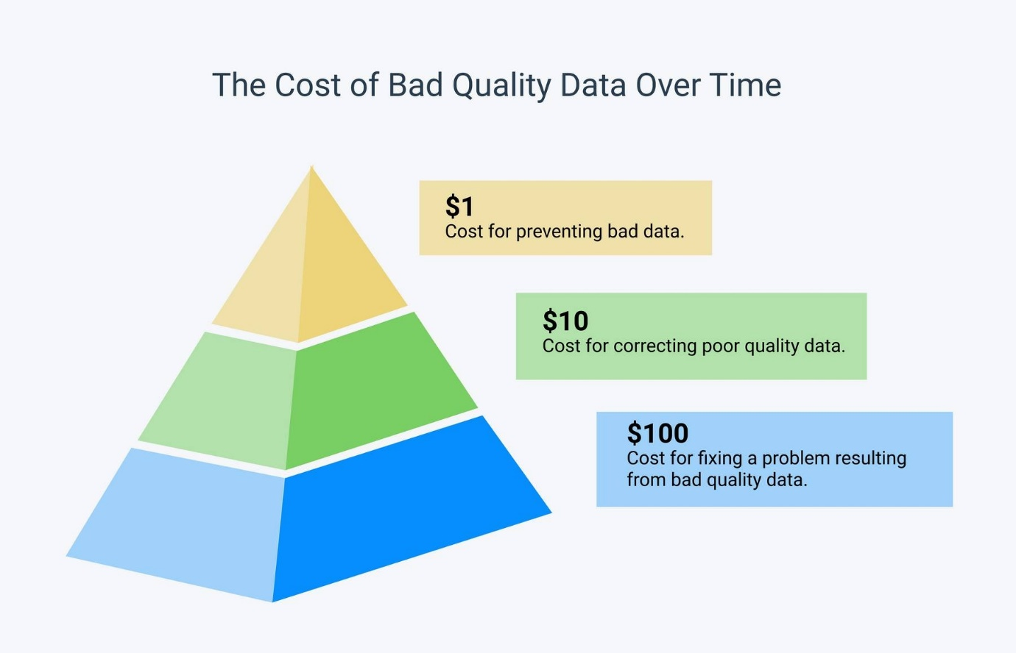

So, it’s important that you perform proper data cleaning to ensure you get the best possible results.

In [machine learning](https://monkeylearn.com/machine-learning/), data scientists agree that better data is even more important than the most powerful algorithms. This is because machine learning models only perform as well as the data they’re trained on.

Data Cleaning Steps & Techniques

Here is a 6 step data cleaning process to make sure your data is ready to go.

* **Step 1:** [Remove irrelevant data](https://monkeylearn.com/blog/data-cleaning-steps/#remove)
* **Step 2:** [Deduplicate your data](https://monkeylearn.com/blog/data-cleaning-steps/#deduplicate)
* **Step 3:** [Fix structural errors](https://monkeylearn.com/blog/data-cleaning-steps/#fix)
* **Step 4:** [Deal with missing data](https://monkeylearn.com/blog/data-cleaning-steps/#missing)
* **Step 5:** [Filter out data outliers](https://monkeylearn.com/blog/data-cleaning-steps/#filter)
* **Step 6:** [Validate your data](https://monkeylearn.com/blog/data-cleaning-steps/#validate)

Data Cleaning Tips

* **Create the right process and use it consistently**

Set up a data cleaning process that’s right for your data, your needs, and the tools you’ll use for analysis. This is an iterative process, so once you have your specific steps and techniques in place, you’ll need to follow them religiously for all subsequent data and analyses.

It’s important to remember that, although data cleaning may be tedious, it’s absolutely vital to your downstream processes. If you don’t start with clean data, you’ll undoubtedly regret it in the future when your analysis produces “garbage results.”

* **Use tools**

There are a number of helpful data cleaning tools you can put to use to help the process – from free and basic, to advanced and machine learning augmented. Do some research and find out what data cleaning tools are best for you.

* **Pay attention to errors and track where dirty data comes from**

Track and annotate common errors and trends in your data, so you’ll know what kinds of [cleaning techniques](https://monkeylearn.com/blog/text-cleaning/) you need to use on data from different sources. This will save huge amounts of time and make your data even cleaner – especially when integrating with analysis tools you use regularly.

## Wrap Up

It’s clear that data cleaning is a necessary, if slightly annoying, process when running any kind of data analysis. Follow the steps above and you’re well on your way to having data that’s fully prepped and ready for downstream processes.

# ***Data Accuracy and Consistency***

If you care about whether your business succeeds or fails, you should care about data accuracy. Data accuracy is important because it has an impact on your company's bottom line. Unfortunately, that impact often goes undetected—until it’s too late.

Say your [business uses data for operational purposes](https://www.metaplane.dev/blog/how-low-quality-data-hurts-business-performance), and your data is inaccurate. You could upset an entire segment of customers whose names you got wrong in an email—damaging your reputation and losing their trust. Or, you could lose profitable sales because you inadvertently listed an in-demand item as “out of stock” on your ecommerce website.

### **Introduction to Data Quality**

There are many varying definitions of “data quality”, with some definitions defining it with terms such as “accurate data” or “timeliness”, but we take a more robust approach to defining data quality to help you inform your data management strategy for you toa void all possible data quality issues.

Data accuracy is one of [ten dimensions of data quality](https://metaplane.dev/blog/data-quality-metrics-for-data-warehouses#introduction-to-data-quality-dimensions-and-metrics), and one of three dimensions that influence data integrity. Data is considered accurate if it describes the real world. Ask yourself: Do the entities actually exist in your data collection, do they have the attributes you describe in your data

Data, the lifeblood of modern organizations, flows through various systems, sources, and processes. However, ensuring that this data remains accurate, coherent, and aligned with predefined standards is a multifaceted challenge. This is where data consistency comes into play.

Data consistency refers to **the quality of data being uniform, accurate, and coherent across various databases, systems, and applications within an organization.**

In this article, we will learn the core concepts of data consistency, and provide examples that showcase its impact across industries.

## Data consistency:

## Data consistency refers to the **quality of data being uniform, accurate, and coherent across various databases, systems, and applications within an organization.** It ensures that data remains the same and aligns with the established rules and standards throughout its lifecycle, regardless of the platform or location it’s accessed from.

### Importance of data consistency

Data consistency is crucial for several reasons that extend beyond simple accuracy. It’s a cornerstone of effective [data management](https://atlan.com/data-management-101/?ref=/data-consistency-101/) and informed decision-making. Here’s a deeper look at its significance:

#### 1. Reliable decision-making

* Inaccurate or inconsistent data can lead to misguided decisions.
* If different departments or systems present conflicting information, it becomes challenging to determine the correct course of action.
* [Data-driven decisions](https://atlan.com/data-driven-decision-making/?ref=/data-consistency-101/) rely on the assumption that the data is accurate and consistent.
* Inconsistent data can lead to poor strategic choices, erode trust in analytics, and hinder business growth.

#### 2. Operational efficiency

* Consistent data streamlines business processes.
* Employees can work more efficiently when they’re confident in the accuracy and reliability of the information they’re using.
* Inconsistent data can lead to wasted time as employees try to reconcile differences or correct errors.
* This inefficiency can delay projects and impede productivity.

#### 3. Customer trust and satisfaction

* When customer data isn’t consistent, it can lead to misunderstandings and inaccurate interactions.
* Customers expect businesses to have accurate and up-to-date information about their preferences and history.
* Sending contradictory messages or not recognizing customer interactions can damage the relationship, erode trust, and result in lost opportunities for upselling or personalized experiences.

#### 5. Legal and regulatory compliance

* Some industries are subject to strict data regulations that require accurate and consistent data storage and reporting.
* Failure to comply can result in legal consequences and financial penalties.
* Inconsistent data can lead to non-compliance with data protection laws.
* This results in lawsuits, fines, and damage to a company’s reputation.

#### 6. Data integration and analysis

* Organizations use data from various sources for analysis.
* Inconsistent data makes integration and analysis complex, leading to incomplete insights and inaccurate conclusions.
* Inaccurate insights can misguide critical business strategies, leading to missed opportunities or misguided investments.

#### 7. Efficient collaboration

* Collaboration across departments relies on shared data.
* Inconsistent data can lead to misunderstandings, miscommunication, and delays when teams rely on different versions of the truth.
* Without data consistency, collaboration breaks down, impeding innovation and alignment between different parts of the organization.

In essence, data consistency ensures that the data used across an organization is dependable, accurate, and aligned with the objectives and standards of the business.

Companies that prioritize data consistency not only mitigate risks but also create a solid foundation for growth and innovation in the data-driven era.

1. Manual data entry
2. Data duplication
3. Lack of data standards
4. Integration challenges
5. Legacy systems
6. Data migration
7. Lack of data governance
8. Incomplete updates
9. Organizational changes
10. Lack of training and awareness